# ListLab1, extended

# Recall that we introduced the ListNode class. Here is the ListNode API:

|  |  |  |
| --- | --- | --- |
| **Constructor Summary** | | |
| [**ListNode**](http://www.tusdnet.k12.ca.us/THS/Academics/APCS/JavaAPAPI/ap/ListNode.html#ListNode(java.lang.Object, ap.ListNode))(java.lang.Object initValue, [ListNode](http://www.tusdnet.k12.ca.us/THS/Academics/APCS/JavaAPAPI/ap/ListNode.html) initNext)            Construct a list node with specified value and next node. | |  |
| **Method Summary** | | |
| [ListNode](http://www.tusdnet.k12.ca.us/THS/Academics/APCS/JavaAPAPI/ap/ListNode.html) | [**getNext**](http://www.tusdnet.k12.ca.us/THS/Academics/APCS/JavaAPAPI/ap/ListNode.html#getNext())()            Returns the next node after this node. | |
| java.lang.Object | [**getValue**](http://www.tusdnet.k12.ca.us/THS/Academics/APCS/JavaAPAPI/ap/ListNode.html#getValue())()            Returns the value stored in this node. | |
| void | [**setNext**](http://www.tusdnet.k12.ca.us/THS/Academics/APCS/JavaAPAPI/ap/ListNode.html#setNext(ap.ListNode))([ListNode](http://www.tusdnet.k12.ca.us/THS/Academics/APCS/JavaAPAPI/ap/ListNode.html) theNewNext)            Sets the next node after this node | |
| void | [**setValue**](http://www.tusdnet.k12.ca.us/THS/Academics/APCS/JavaAPAPI/ap/ListNode.html#setValue(java.lang.Object))(java.lang.Object theNewValue)            Sets the value stored in this node. | |

# Exercises

1. Draw a picture of the linked list constructed by the following commands.

ListNode p = **new** ListNode("board", **null**);

ListNode a = **new** ListNode("college", p);

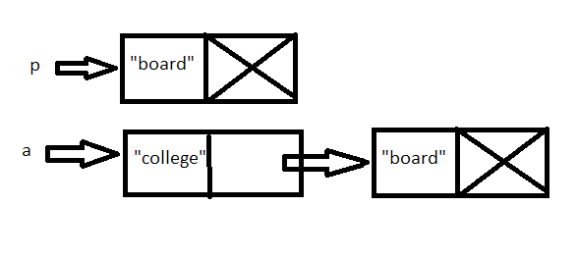

2. Implement the three methods below.

// returns a new node that is a copy of the argument node.

**public static** ListNode copyNode(ListNode arg)

{

if(arg == null)

return null;

return new ListNode(arg.getValue(), arg.getNext());

}

// returns a new list that is a copy of the original list.

// this method is recursive!

// example call: ListNode head2 = copyList(head);

**public static** ListNode copyList(ListNode arg)

{

if(arg == null)

return null;

return new ListNode(arg.getValue(), copyList(arg.getNext()));

}

//returns a new linked list containing copies of each node in //the original list except the first node, maintaining the //order of the original list. It is not correct to just //return a pointer to the 2nd node of the original linked //list. This method is recursive.  
**public static** ListNode rest(ListNode h)  
{

if(arg == null)

return null;

return copyList(h.getNext()));

}

3. Write the following six methods that operate on a linked list of ListNode objects. You may wish to make use of the three methods above.

// returns the value of the first node, or null if the list is empty

**public static Object** first(ListNode head)

// returns the value of the second node, or null if the list is empty or if there is only one node. // hint: second could call the first of rest.

**public static Object** second(ListNode head)

//returns a reference to the last node in the list, or null if the list is empty.

**public static** ListNode pointerToLast(ListNode head)

//returns a copy of the last node (not just its value!). copyofLast can be recursive.

**public static** ListNode copyOfLast(ListNode head)

//returns a reference to a list whose first node's value is specified by the argument, and the

//first node's next links to the original list.

**public static** ListNode insertFirst(ListNode head, Object arg)

//returns a reference to a list whose last node's value is specified by the argument, such

//that this last node has been appended to the original list and had its next is set to null

**public static** ListNode insertLast(ListNode head, Object arg)

# Assignment

Open ListLab1 and write all nine (9) methods above. The driver is given to you.

Sample run:

[computer, science, java, coffee, nonsense, boo, foo, hello]  
[computer, science, java, coffee, nonsense, boo, foo, hello]  
The head has a value "computer" at ListNode@15db9742  
The copy of head has a value of "computer" at ListNode@6d06d69c  
Copy the list: [computer, science, java, coffee, nonsense, boo, foo, hello]  
The rest of the list: [science, java, coffee, nonsense, boo, foo, hello]  
First of the rest = science  
Second of the rest = java  
Pointer to Last = hello at ListNode@7852e922  
Copy of Last = hello at ListNode@4e25154f   
Insert what? p  
[p, science, java, coffee, nonsense, boo, foo, hello, p]